**Installation Guidelines for Arduino IDE**

Arduino IDE was used as it is easy to operate and supports wide range of compatible micro controllers such as ESP32 Wrover Type B which was used in my project and it provides open-source platform to run, compile and upload the code, it also supports broad range of libraries.

Below are the step-by-step installation guidelines for Arduino IDE:

**Step 1:** To install Arduino IDE, we should go to: *https://www.arduino.cc/en/software/* where the OS should be selected according to your device compatibility.

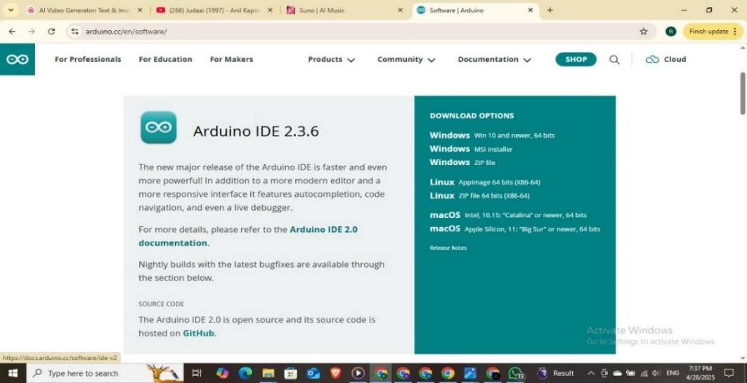

**Step 2:** Then, click I Agree, which should start the installation.

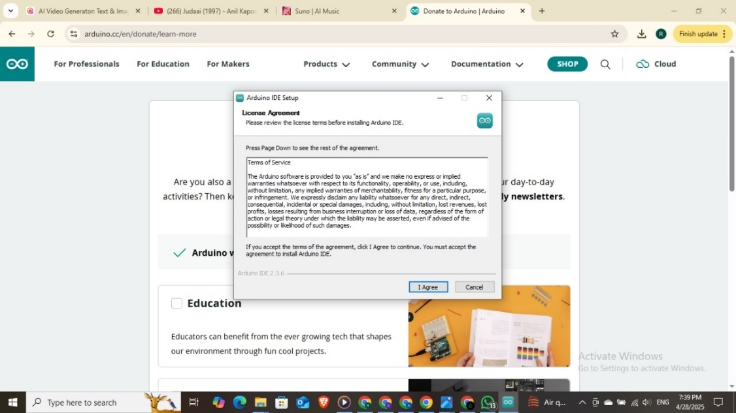

**Step 3:** After that, select the destination folder - where you want to keep your application. Then click on install which should start the installation.

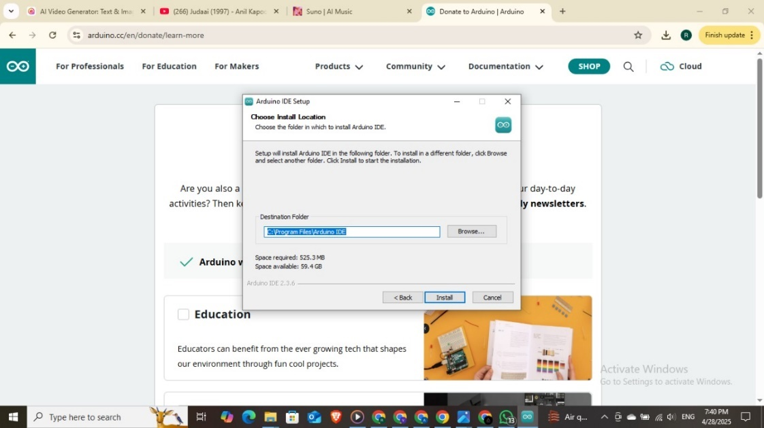

**Step 4:** The setup is completed after the “Completing Arduino IDE Setup” screen is seen as below. Click on Finish to run Arduino IDE.

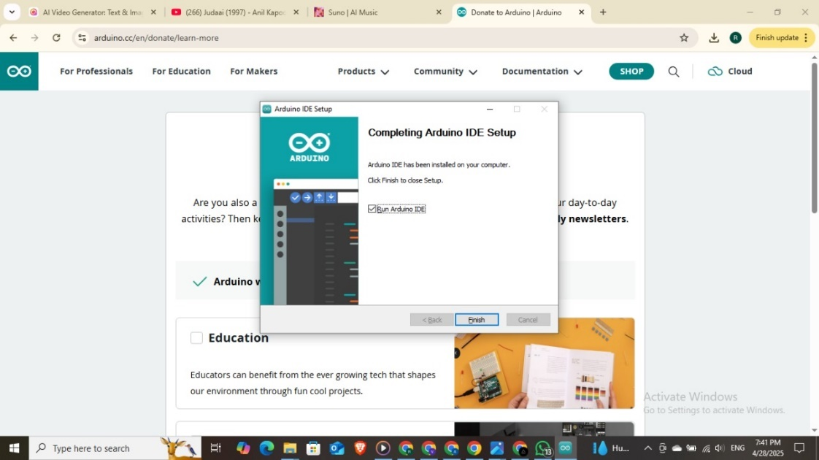

**Step 5:** As you can see, the Arduino IDE is setup and now you start coding.

